MINISTRY OF EDUCATION AND SCIENCE OF UKRAINE

NATIONAL TECHNICAL UNIVERSITY

“KHARKOV POLYTECHNICAL INSTITUTE”

LABORATORY WORK № 3

# “Use of Functions”

Created by student of 1.КН.201.8г

Chukwu Irele Omike

Checked by

LUTENKO I.V

KHARKIV 2018

# Topic: Use of Functions.

Goal: Learning to declare functions , functions overloading and fuctions references.

Tasks:

### 1.1 Static Local Variables

Write a program that calculates and shows the minimum and maximum of integers as the user inputs those integers. Use static local variables.

### 1.2 Recursion

Write a program that reads **x** and **n** and calculates **y** using recursive function:

*y* = (*x* + 1)(*x* + 2)(*x* + 3)(*x* + 4) ... (*x* + *n*)

### 1.3 Default Arguments

Create a function that returns 1, argument, and product of arguments, depending on arguments count. Test this function in main() function. Implement program in two ways: using function overloading and using default arguments.

### 1.4 Quadratic Equation

Create a function for solving of quadratic equation. Function should return **false** if discriminant is less than zero and **true** otherwise. Function should obtain coefficients as arguments and return roots as reference type arguments.

### 1.5 Individual Assignment

You should create a program that implements an assignment of [previous laboratory training](http://iwanoff.inf.ua/programming_1/LabTraining02.html). Program should be split into several functions. Function y() should obtain values of x and n as arguments and return value calculated using formula given in an individual assignment. Create a separate function for reading data. Do not use global variables.

Task 1 : the code

#include<iostream>

using namespace std;

int f(int a)

{

static int max, min;

if (a >= max&&a > min)

{

max = a;

return max;

}

else if (a < max&&a <= min)

{

min = a;

return min;

}

else

return a;

}

int main()

{

int a, max, min;

cin >> a;

max = min = a;

cout << "max = " << max << " \n" << "min = " << min << endl;

for (;;)

{

cin >> a;

f(a);

if (a >= max)

max = a;

else if (a <= min)

min = a;

cout << "max = " << max << " \n" << "min = " << min << endl;

}

}

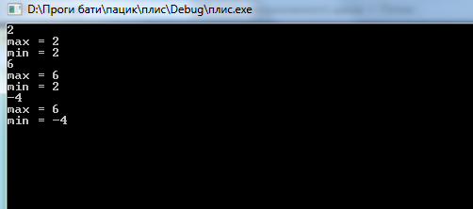

Task 2:

#include "stdafx.h"

#include <iostream>

using namespace std;

int f(int x, int n)

{

if (n == 0)

return 1;

else

return (x + n)*f(x, n - 1);

}

void main()

{

int x, n;

cin >> x >> n;

cout << f(x, n) << endl;

system("PAUSE");

}

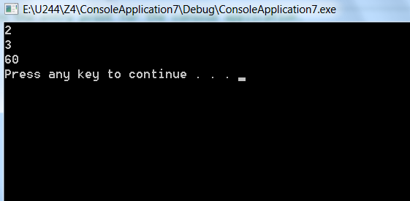

Task 3:

#include <iostream>

using namespace std;

int sum(int x);

int f(int x);

int f(int x, int y,int a);

int main()

{

int x;

int y;

int a;

cin >> x>>y>>a;

cout << f(x) << endl;

cout << f(x, y,a) << endl;

cout << sum(x) << endl;

return 0;

}

int f(int x)

{

return x;

}

int f(int x, int y, int a)

{

return x*y*a;

}

int sum(int x)

{

return 1;

}

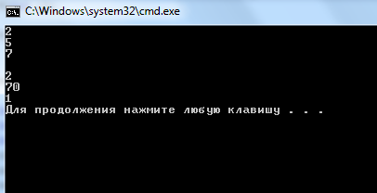

Task 4:

#include <iostream>

using namespace std;

double z(double a, double b, double c, double &x1, double &x2);

int main()

{

double a, b, c;

cout << "Input a ,b ,c" << endl;

cin >> a;

cin >> b;

cin >> c;

double x1 = 0;

double x2 = 0;

if (z(a, b, c, x1, x2) == -1)

{

cout << "No roots" << endl;

}

else if (z(a, b, c, x1, x2) == 1)

{

cout << "x1=" << x1;

}

else {

cout << "x1=" << x1 << "\n" << "x2=" << x2 << endl;

}

return 0;

}

double z(double a, double b, double c, double &x1, double &x2)

{

double D;

D = (b*b) - (4 * a*c);

D = sqrt(D);

if (D < 0)

return -1;

else if (D == 0)

{

x1 = -b / 2 * a;

return 1;

}

else

{

x1 = (-b - D) / (2 * a);

x2 = (-b + D) / (2 * a);

return 2;

}

}

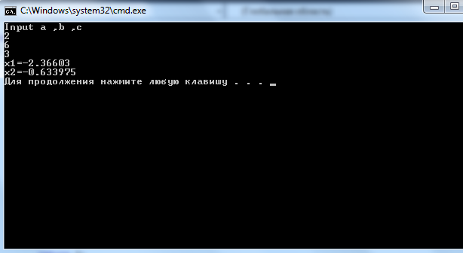

**Individual Assingment:**

#include "pch.h"

#include <iostream>

#include <math.h>

using namespace std;

int getX()

{

int x;

cout << "input x: ";

cin >> x;

return x;

}

int getN()

{

int n;

cout << " \n input n ,n should be greater than 0 'zero': ";

cin >> n;

return n;

}

double functionY(int x, int n)

{

int i, j;

double y = 0, z;

if (x < 0)

{

for (i = 1; i < n + 1; i++)

{

y = y + (i + x) * (i + x);

}

return y;

}

else

{

for (i=0; i < - 1; i++)

{

z = 1;

for (j = 1; j <= n; j++)

{

z = z * ((x + i) / (i + j));

}

y = y + z;

}

return y;

}

}

int main()

{

cout << "the result of the function of x is : " << functionY(getX(), getN()) << endl; ;

}

